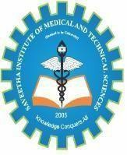

Saveetha Institute of Medical and Technical Sciences Chennai- 602105

Student Name: G Venkatesh Reddy Reg. No.: 192372262
Course Code: CSA4308 Slot: A
Course Name: INTERNET PROGRAMMING
Course Faculty: RAJAGOPAL K

Project Title: Food Donation and Distribution Management System
Module Photographs:
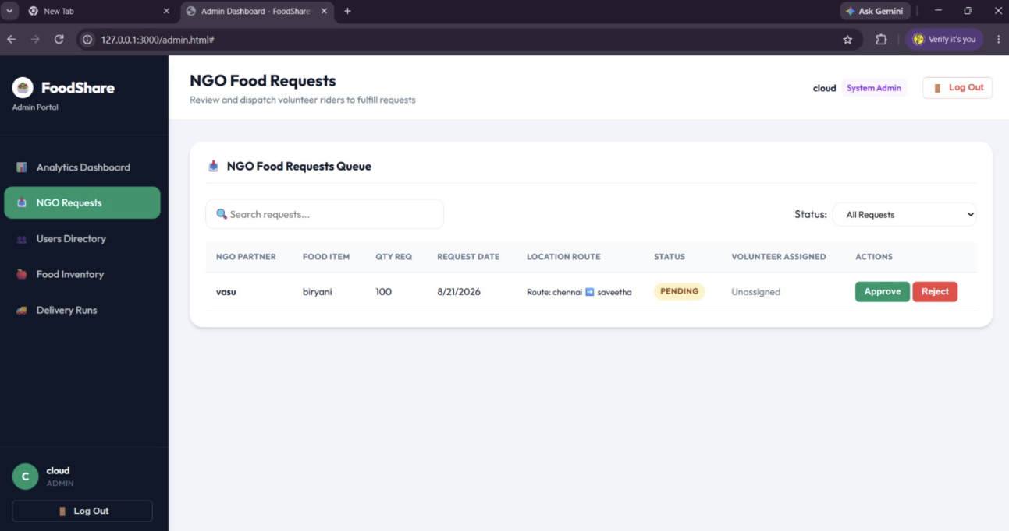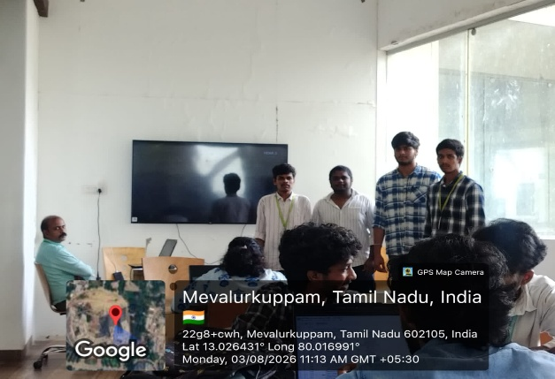
APPLICATION Presentation Image
Project Description: Module 3:Food Request Management
Food Donation and Distribution Management System is a web-based platform developed to reduce food wastage and improve the distribution of surplus food to people in need. The system provides a common platform for food donors, NGOs, volunteers, and administrators to coordinate food donations efficiently.

Food donors such as restaurants, hotels, event organizers, and individuals can register and post details about available food, including food type, quantity, expiry time, pickup location, and contact details. NGOs and volunteers can view available donations and accept suitable requests for collection and distribution.

The administrator can manage users, monitor donations, verify requests, and maintain distribution records. The system can also provide real-time donation status, such as Available, Accepted, Picked Up, and Distributed. This improves transparency and helps prevent food from being wasted due to delays.

